The Battle of Neighbourhoods – Thai Restaurants

**Introduction**

Thai people trend to move to New York more and more and one of the most famous things in Thailand is Food. Opening the restaurants or working in restaurants is seem to be great job for those who move to New York

This Project is made to help people who moving to New York to make an easier decision where is the most suitable place to open then restaurant and which restaurants should they working with.

**Data**

New York data

-Neighborhoods

-Boroughs

-Latitude& Longitude

From : <https://cocl.us/new_york_dataset>,

Restaurants data

-Rating

-Location

From : FourSquare API

**Methodology**

1. Collect, clean and process New York data
2. Use Foursquare to find Thai restaurants and import detail (Rating, tips, likes)
3. Sort the data
4. Visualize the data

**Problem Statement**

1. Where are the best locations for opening Thai cuisine in New York City?
2. Which Neighborhood has high restaurants competition?
3. Which Thai restaurants are famous and should work with ?

Results

1.We see that Queens has the highest number of Neighbourhoods.

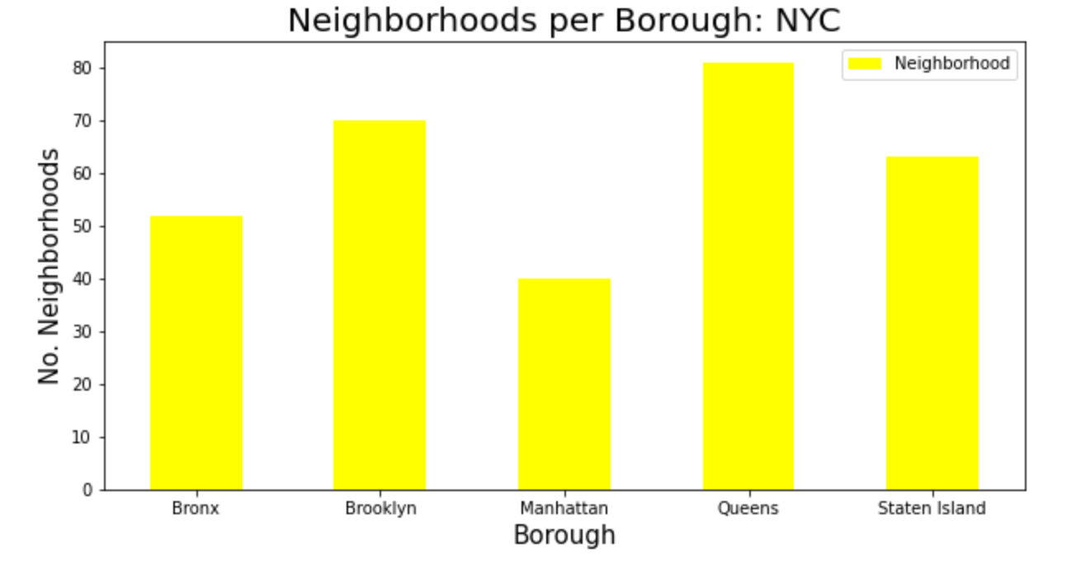

2. But high number of Thai Restaurants are in Brooklyn and Manhattan.

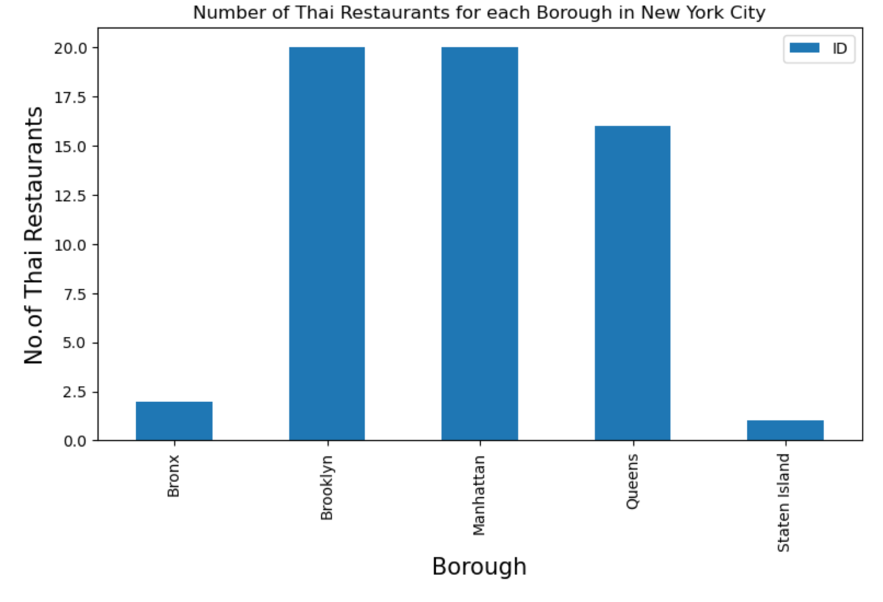

3. Manhattan has the highest average rating for Indian Restaurants.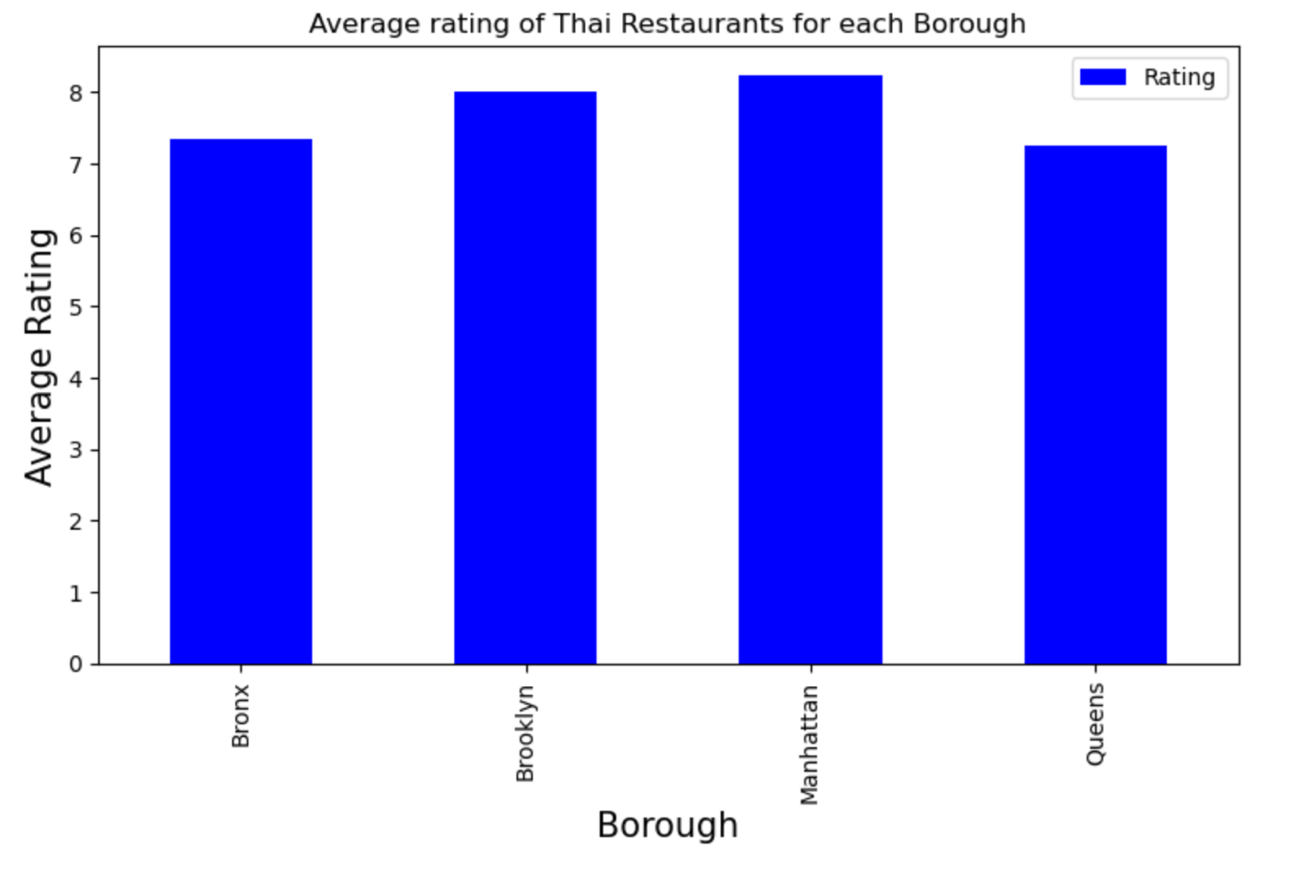

4. Rating for each Borough

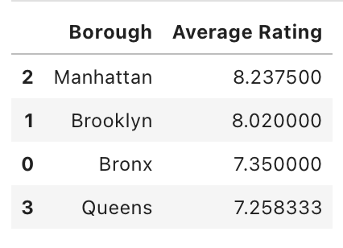

5. Manhattan and Brooklyn have highest average rating for Thai Restaurants.

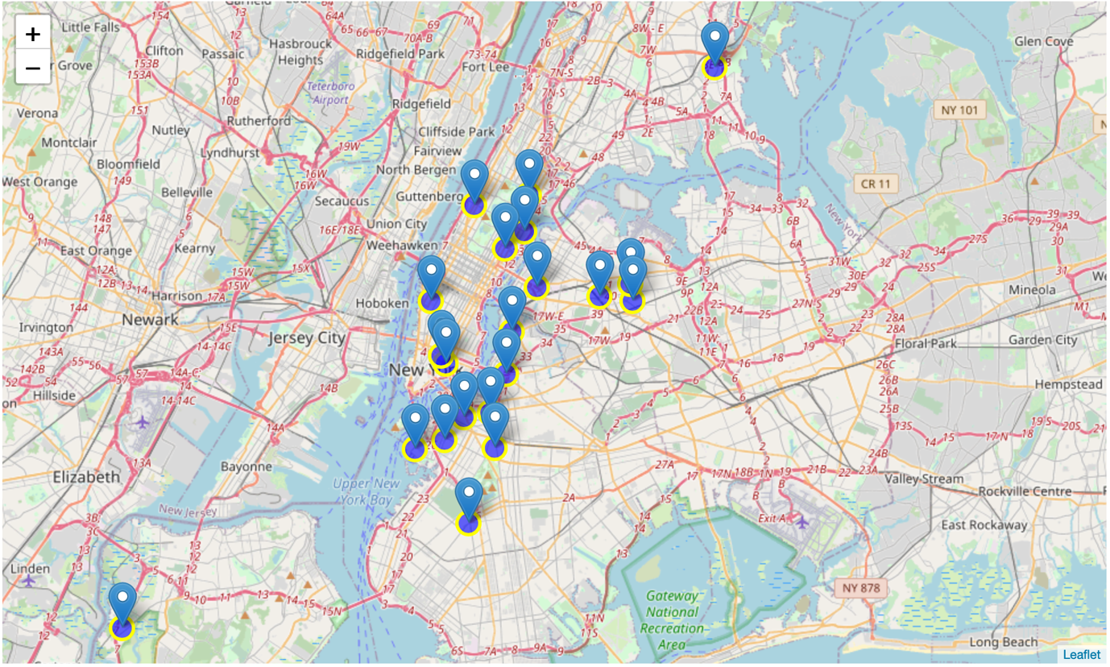

## Results / Conclusion

Brooklyn have the best rated Thai restaurants on average and have high number of Thai restaurants. Number of neighbourhoods in queen is the highest but number of Thai restaurants and quality of them is quite lower than it should (Manhattan = 8.2, Brooklyn = 8.0, Queen = 7.2).

The Conclusion are

1. Borough for opening the restaurants is Queens because high neighbourhoods but low number and quality of restaurants.
2. Manhattan and Brooklyn are the good place for opening the restaurants because of high competition
3. Manhattan is good borough for people who want to work in restaurants because of high number of restaurants.